**The srs electrical lab autoamtion**

**PROJECT GROUP MEMBERS**

|  |  |
| --- | --- |
| **STUDENT ID** | **STUDENT NAME** |
| Student:1340130 | Aliyan Javed |
| Student:13040168 | Zaid |
| Student:1340182 | Usman Nasir |
| Student:1339512 | Daniyal Hussain |

**CURRICULUM:**

6740

**Batch:**

2110F1

**Faculty of department**

Miss Muniba Javed

**Co-Ordinator**

Miss Iqra Khan

**User-guide:**

A user guide, also commonly known as a user manual, is **intended to assist users in using a particular product, service, or application**. It's usually written by a technician, product developer, or a company's customer service staff.

**User-guide Includes:**

1. Plain Languages
2. Simplicity
3. Visuals­­­­­­
4. A focus on the problem
5. Logical hierarchy and flow
6. A table of content
7. Good design

**Snapshots**

**Navbar**

****Responsive Navigation

**Home Page**

When user open our website, they will see this user-

friendly home page.

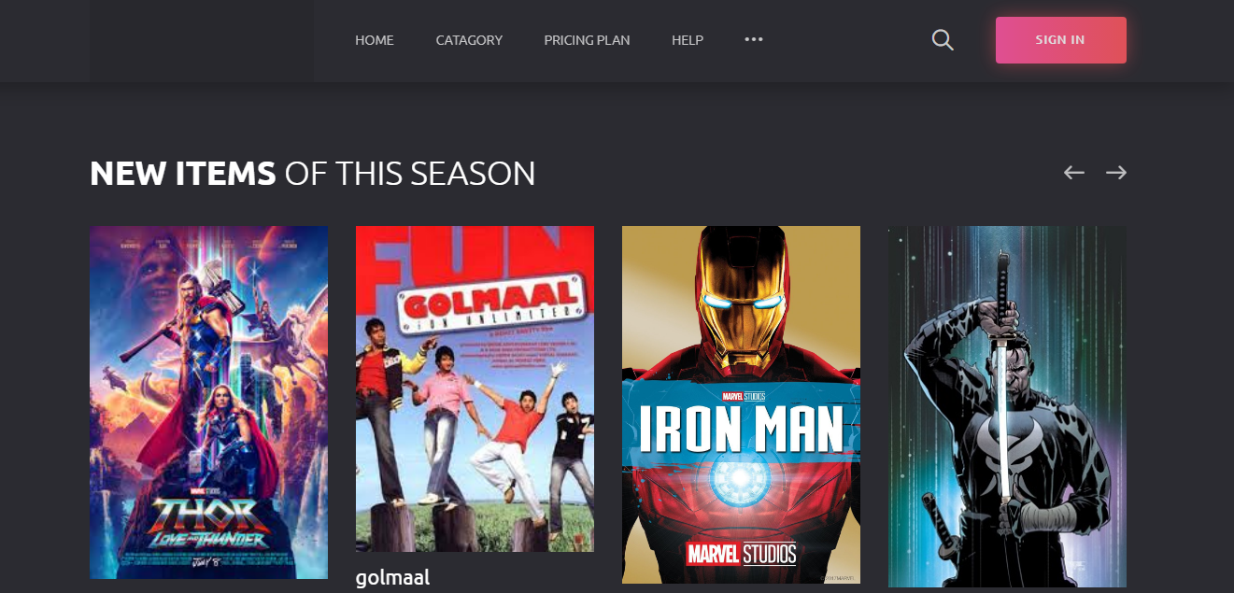

**DETAIL PAGE**

When user click on a film card it shows a detail page.



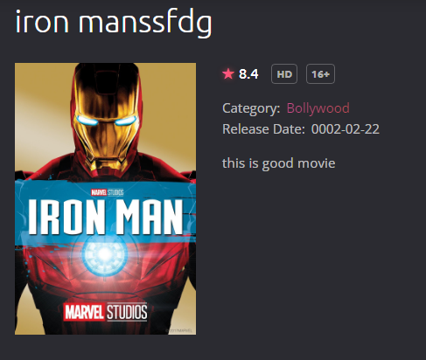

**Login form**

In this curriculum we have one user admin user.

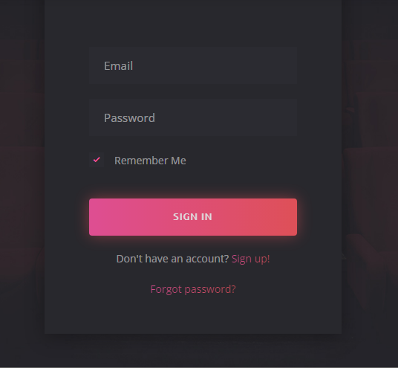

Admin site

category

Add category:

In this page, how to add a category with the help of category form.

* Fill-up a user add form
* All fields are mandatory
* Generate a password
* Form Submit

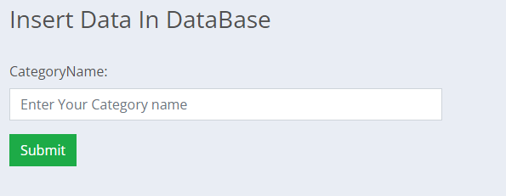Now a user is successfully register in website.

View-Category:

In this page, we have shown an item what we are added some categories in view data product.

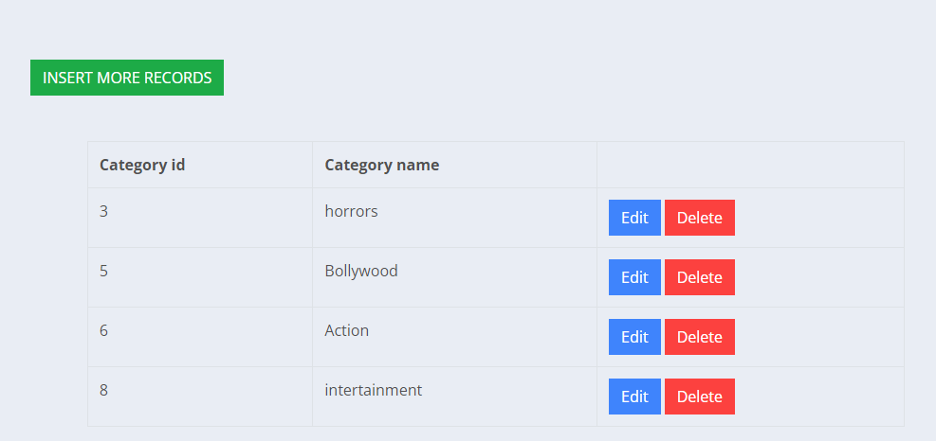

* If a user switch to edit button so we have changed the product and then click on update button the product is updated.

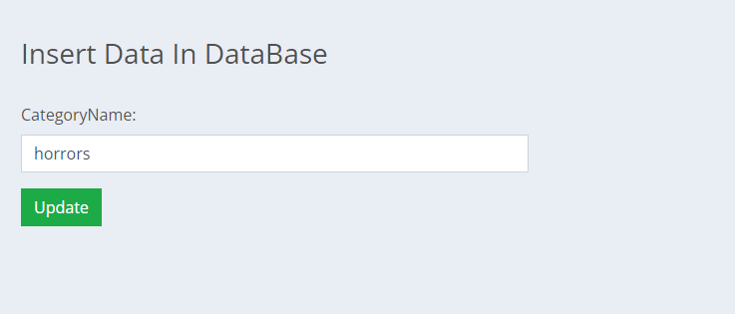

* If a user switch to delete button the product is deleted and after deleted a product it will generate a message.

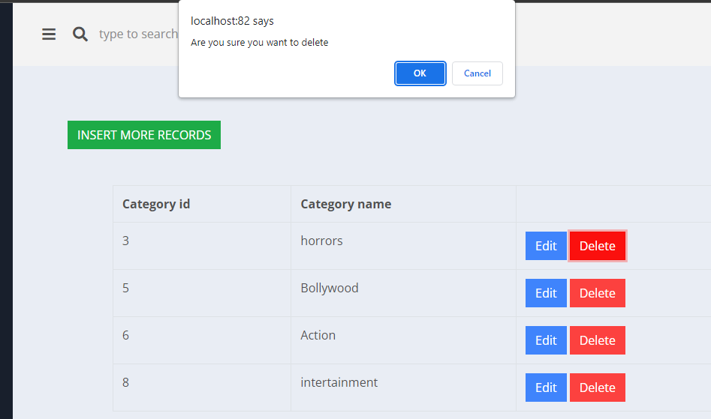

products

add products:

A user can add a product with the help of add product form.

User must fill-up all the requirements

* Product name
* Status
* Description
* Image
* Click on submit button

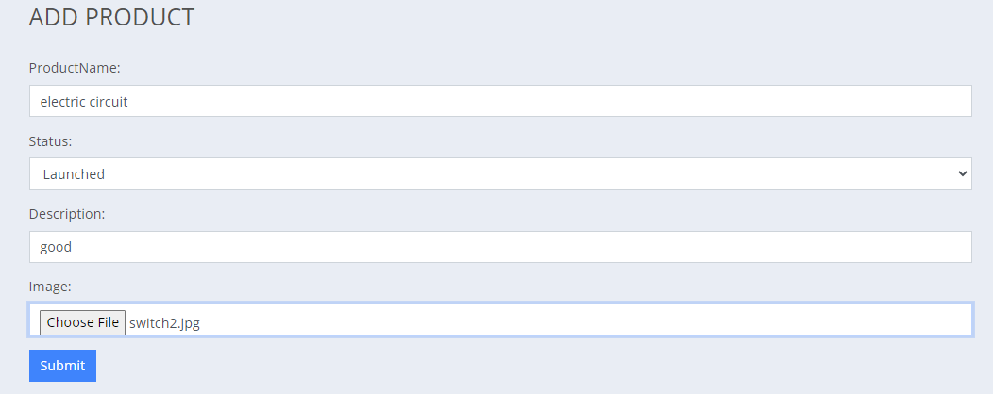

* Product is successfully added

company site

products

testing-products

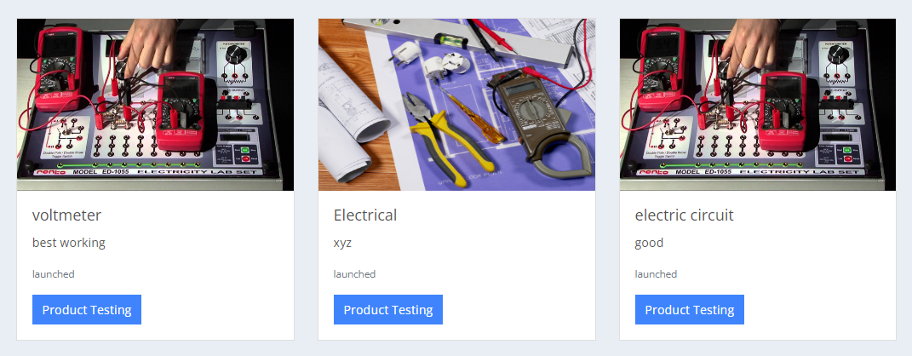In this page we must focus on how company test the product. We have to show some of our products.

* If a company user clicks on product testing, we have move to company tester form.
* Now fill-up the form.
* Submitted

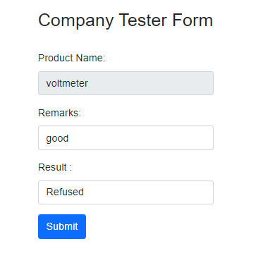

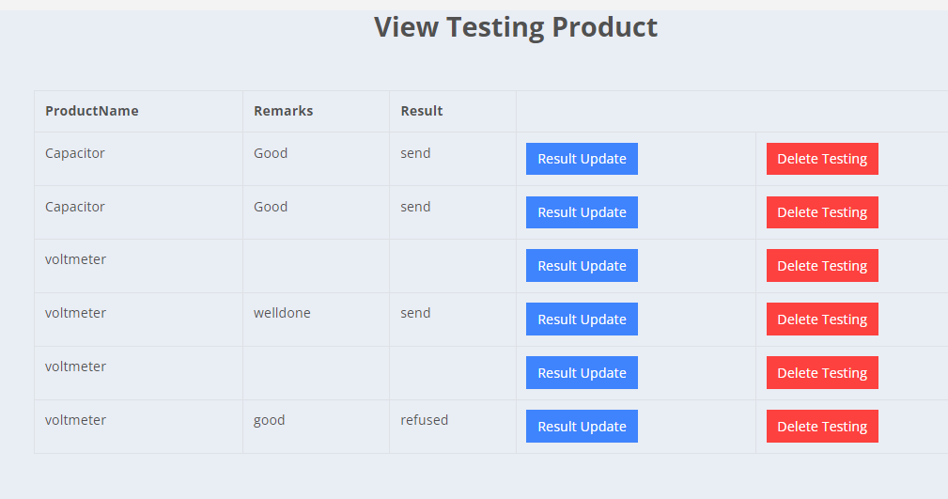

* If a company user switch to result update button the edit form is open, then the product is updated.

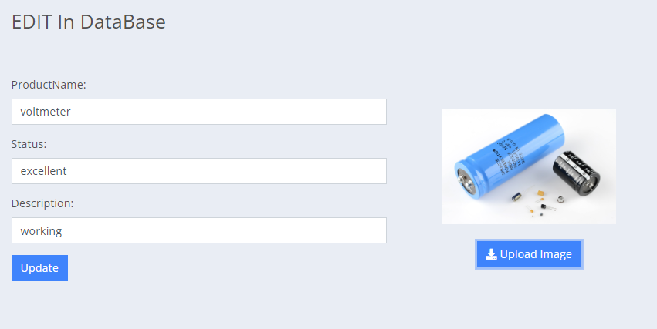

* If a user redirects the page and click on delete button the product is deleted and generate a message.

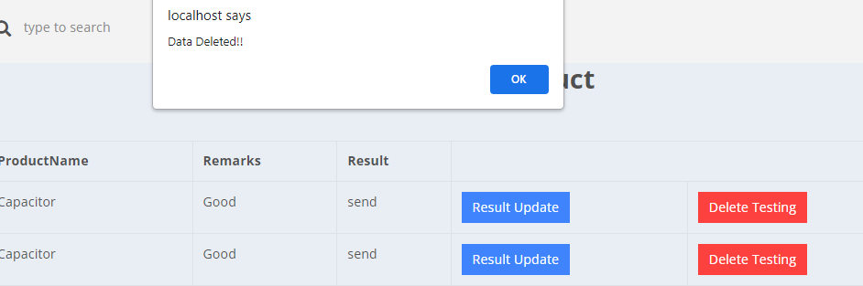

Erd diagram

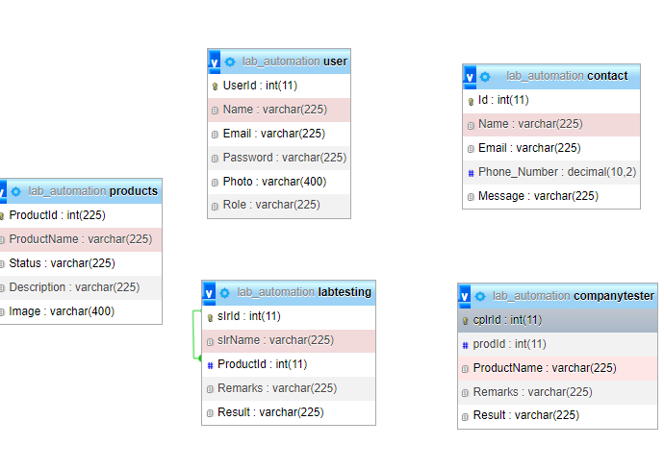

Thanks for reading the

USER guide